**Crack The Loop**

On the Ghost Town forum, several encrypted papers have been circulated. Someone just posted a URL to a web color template when they were asked for the password. We're not sure how to interpret this. Do you also?

**Writeup:**

On the Ghost town forum, we discover the following posts:



If we read the hex value of the color of each block by clockwise direction .

(I personally used this online tool: https://imagecolorpicker.com/en)

BY clockwise direction we get :

#010101

#0c041a

#1e0b40

#270f54

#1d0d5c

#1e0d5e

Combine all of those values into one string:

0101010c041a1e0b40270f541d0d5c1e0d5e

Now all we need is a tool to change the above output from hex.

I used Cyberchef (a tool I highly recommend for any cryptography CTF challenge) and the result was:

‑  
@'T\‑^

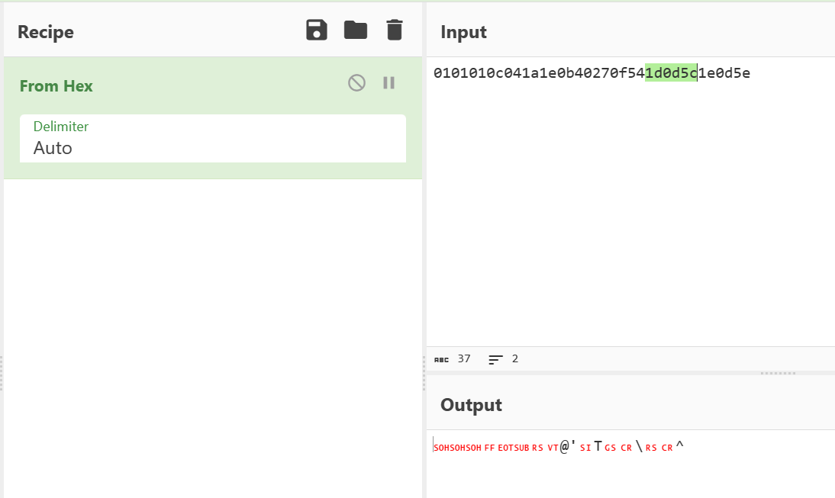

Once you get the output , the output is a password of a file which contains flag .

By opening file by simply clickin on find(ctrl + F) and searching only CTF you get a flag.